# Section 3: The Life of Ascetic Siddhartha (Ages 29–35)

This section recounts one of the most profound moments in history—the great renunciation of Prince Siddhartha. At the age of twenty-nine, he left behind the comforts of his royal life, his beloved family, and the promise of kingship, driven by an unshakable determination to seek the ultimate truth.

With a heart filled with compassion for all beings, he wandered in search of wisdom, learning from renowned teachers and mastering their doctrines. Yet, realizing that these teachings did not lead to the highest liberation, he embarked on an austere path of self-mortification, enduring six years of extreme asceticism. During this period, he was known as “Ascetic Siddhartha.” His relentless pursuit of truth and his unwavering resolve to overcome suffering would soon illuminate the path for countless beings.

When he finally attained supreme enlightenment, he became the Buddha, the Fully Awakened One. In later times, he was often respectfully addressed as “Buddha Gotama” or “Ascetic Gotama,” honouring both his noble renunciation and his boundless wisdom

This sacred journey of the Prince Siddhartha —marked by renunciation, struggle, and ultimate triumph—continues to inspire seekers across generations, reminding us of the immeasurable courage and boundless compassion that led to the dawn of the Dhamma.

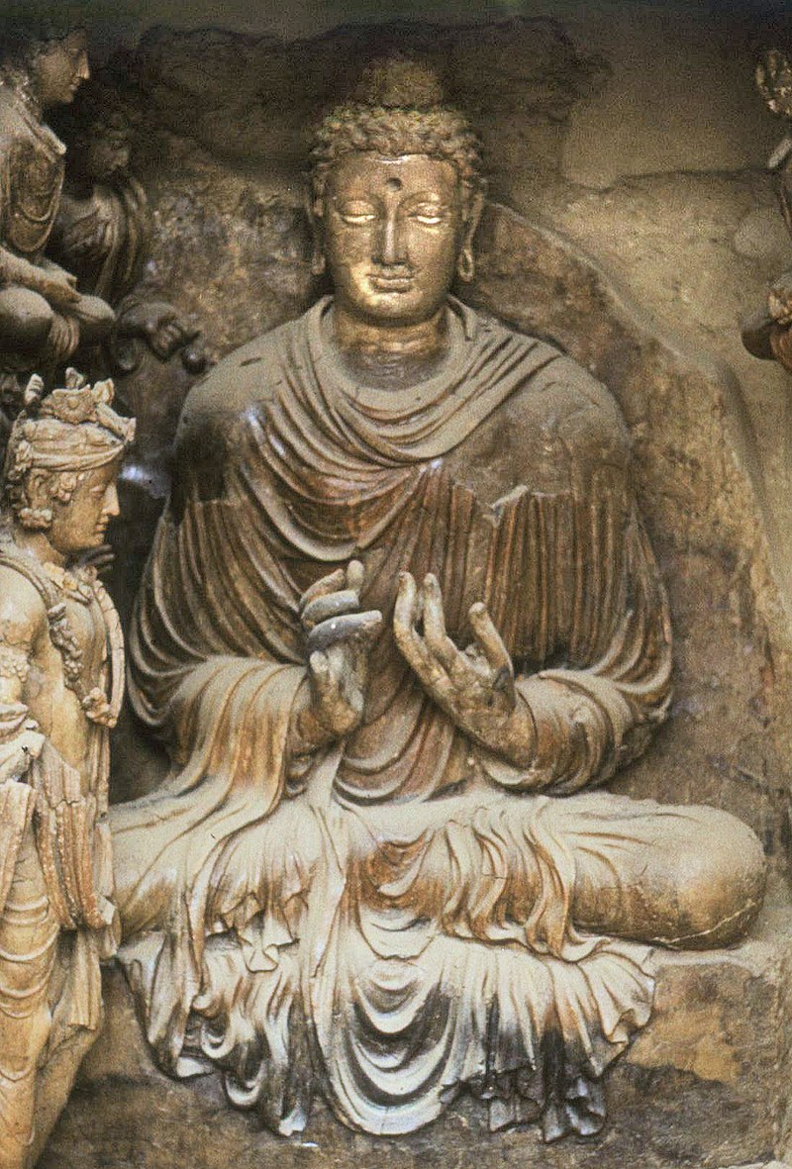

**Ancient Image of the Buddha** [1]

## The Great Renunciation

According to legend, the Great Renunciation (*Mahā Abhinikkhamana*) of Prince Siddhartha took place on the full moon day of Āsāḷha (Esala) in the year 595 B.C. [2]

As recorded in the scriptures, the Buddha later reflected on his going forth with these words:

“I went forth seeking what is good—  
Twenty-nine years of age I was…  
When I went forth to seek the Good.  
Now over fifty years have passed  
Since the day that I went forth  
To roam the realm of wisdom’s law…”

(*Ekūnatiṃso vayasā Subhadda,  
Yaṃ pabbajiṃ kiṃkusalānuesī;  
Vassāni paññāsa samādhikāni,  
Yato ahaṃ pabbajito Subhadda.*) *[3]*

The above passage is found in the *Mahāparinibbāna Sutta* (DN 16), where, on the eve of his passing-away, the Blessed One spoke these words to Subhadda, his last personal disciple. [4]

The following extract from this sutta also elaborates Buddha’s wish to go forth:

*‘…. before my enlightenment, while I was still only an unenlightened Bodhisatta, I thought: ‘****Household life is crowded and dusty; life gone forth is wide open. It is not easy, while living in a home, to lead the holy life utterly perfect and pure as a polished shell.*** *Suppose I shave off my hair and beard, put on the yellow robe, and go forth from the home life into homelessness…’* [5]

At the age of twenty-nine, Prince Siddhartha renounced his life of luxury, leaving behind his royal lineage and all worldly comforts, in search of a path beyond the endless cycle of birth, aging, and death—*saṃsāra*—and the suffering it entails. His Great Renunciation stands as one of the most significant events in Buddhist history, a momentous milestone for the entire Buddhist world.

The Buddha’s noble departure set an unparalleled example of renouncing lay life for the path of liberation, inspiring generations of monks and nuns to follow in his footsteps. The world remains indebted to the Buddha Gotama, whose unwavering determination and boundless compassion illuminated the way to true freedom.

### What Inspired Prince Siddhartha to Become an Ascetic?

The profound renunciation of Prince Siddhartha was not an impulsive act, but the culmination of deep insight and reflection. The suttas provide glimpses into what stirred his heart and led him to abandon his royal life in pursuit of the highest truth.

### Witnessing the Suffering of Life—Old Age, Sickness, and Death

The Buddha later recounted:[6]

“Bhikkhus, I was delicately nurtured—most delicately nurtured, extremely delicately nurtured... Yet, amid such splendour and luxury, it occurred to me:

‘I too am subject to old age and am not exempt from it. If I were to feel repelled, humiliated, or disgusted when seeing another who is old, that would not be proper for me.’

When I reflected thus, my intoxication with youth was completely abandoned.

‘I too am subject to illness and am not exempt from it. If I were to feel repelled, humiliated, or disgusted when seeing another who is ill, that would not be proper for me.’

When I reflected thus, my intoxication with health was completely abandoned.

‘I too am subject to death and am not exempt from it. If I were to feel repelled, humiliated, or disgusted when seeing another who has died, that would not be proper for me.’

When I reflected thus, my intoxication with life was completely abandoned…”

These reflections awakened in him a profound understanding of suffering and impermanence. He saw with great clarity that all beings—no matter their status, wealth, or power—are bound by aging, illness, and death. The fleeting pleasures of the world could not offer lasting peace or freedom. With this realization, he set forth in search of a way beyond suffering, seeking the ultimate truth (*kiṃkusalānuesī?*).

### The Buddha’s Own Words on Renunciation

*“While I was dwelling thus,  
Having known the state beyond all grasping,  
I overcame every intoxication—  
Intoxication with health,  
Intoxication with youth,  
Intoxication with life—  
Having seen security in renunciation.*

*Zeal then arose in me, as I clearly saw Nibbāna.  
Now I am incapable of indulging in sensual pleasures.  
Relying on the spiritual life, never will I turn back.”[7]*

Prince Siddhartha’s renunciation was not a rejection of life, but an act of supreme compassion—for himself and for all beings trapped in *saṃsāra*. His journey into homelessness was a path of courage, wisdom, and boundless resolve, leading to the great awakening that would illuminate the world.

According to legend, Prince Siddhartha witnessed four significant omens—an old man, a sick man, a dead body, and a recluse. Reflecting deeply upon them, he became determined to renounce his princely life in search of a higher truth [8]

Apart from a passage in the *Khuddaka Nikāya: Buddhavaṃsa* (quoted below), no other direct reference to these four events leading to Prince Siddhartha’s renunciation can be found in the scriptures. However, traditional Buddhist narratives recount that he first encountered an old person, a sick person, and a dead body in a funeral procession. These sights deeply moved him, making him realize the impermanence of life—that all beings inevitably age, fall ill, and die.

The final omen, that of a serene ascetic, struck him profoundly. The sight of someone who had renounced worldly pleasures in pursuit of inner peace and liberation inspired him to abandon his own luxurious life and seek the path beyond suffering.

*"I lived as a householder for thirty-one years... I saw the four omens and set forth in a horse-drawn chariot. For six years, I undertook arduous and strenuous practices."*

*(Mama ekūnatis vassa gihigeyi vāsa keḷemi... satara pera nimiti dæka, aśva yānayakin abhiniṣkramanaya keḷemi. Mama ṣaḷvasa duṣkaravū pradhāna vīriya keḷemi.)*  
*(Nimittena caturo disvā, assayānena nikkhamin; Chabbassam padhānacaraṃ, acarim dukkaram ahaṃ.) [9]*

The *Mahāpadāna Sutta* (*DN 14*) mentions that Buddha Vipassī, upon seeing the four signs, also left his palace to become an ascetic. This suggests that such omens have played a crucial role in the renunciations of past Buddhas, reinforcing their significance in Buddhist tradition.

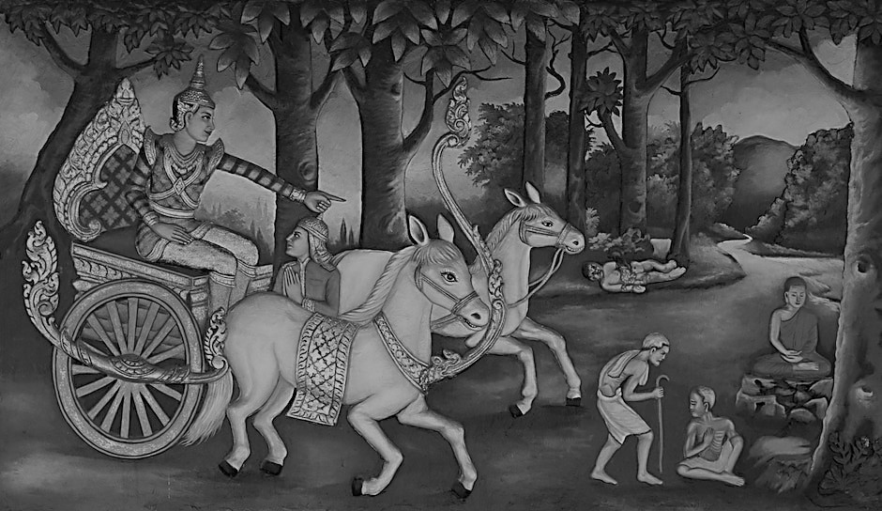

**The four sights: Old Age, Sickness, Death & a recluse [10]**

# Did Prince Siddhartha Leave in the Middle of the Night Without Bidding Farewell to His Family?

The *Great Renunciation* is one of the most profound moments in the life of Prince Siddhartha. In traditional accounts, it is often portrayed as a sudden departure—leaving his loved ones behind without consultation or conversation. However, the suttas provide a deeper perspective, revealing the immense wisdom and compassion that guided his decision.

In the following sutta, the Buddha himself describes the thoughts that led him to renounce the world:

*“Why, being myself subject to birth, do I seek what is also subject to birth? Why, being myself subject to aging, sickness, death, sorrow, and defilement, do I seek what is also subject to aging, sickness, death, sorrow, and defilement?*

*Suppose that, being myself subject to birth, having understood the danger in what is subject to birth, I seek the unborn, the supreme security from bondage...* ***Later, while still young—a black-haired young man, endowed with the blessing of youth, in the prime of life—though my mother and father wished otherwise and wept with tearful faces,*** *I shaved off my hair and beard, donned the yellow robe, and went forth from the home life into homelessness.”* [11]

Though young and surrounded by royal luxuries, Prince Siddhartha saw the true nature of existence—impermanence, suffering, and the endless cycle of birth and death. He realized that worldly pleasures were fleeting and incapable of providing lasting peace. This profound understanding shaped his path toward renunciation.

## A Deeper Understanding of His Departure

It is possible that Prince Siddhartha discussed these truths with his beloved wife, Princess Yasodharā. In the *Jātaka Stories*—which recount the Buddha’s past lives—they had been husband and wife across many lifetimes. In those past lives, whenever the Bodhisatta renounced the world, his wife supported and encouraged him. It is reasonable to believe that in his final life as Prince Siddhartha, she too understood the depth of his aspirations and the nobility of his quest.

Traditional narratives often leave gaps in the story of his renunciation. Yet, when the Blessed One later returned to Kapilavattu, Princess Yasodharā displayed remarkable wisdom and devotion. She pointed out the Buddha to their son, Prince Rāhula, and encouraged him to approach his father, saying:

*“That is your father, dear Rāhula. Go to him and ask for your inheritance.”* [12]

What inheritance could the Buddha offer his son? A *Sammāsambuddha* possesses no material wealth, no kingdom, no treasures. The only gift he could bestow—the greatest gift in the world—was the path to liberation, the way to be free from *saṃsāric* suffering.

Princess Yasodharā, a wise and loving mother, understood this truth. She did not cling to worldly attachments but instead guided her son toward the highest refuge.

## The Compassion Behind His Departure

Would a being of such boundless wisdom and compassion leave without any parting words? It is unlikely. A prince destined to become the Buddha, who deeply loved his family, would not have abandoned them thoughtlessly.

His renunciation was not an act of disregard but of profound love—love that extended beyond a single lifetime, beyond personal relationships, toward the liberation of all beings. He set forth on this noble journey, not to turn away from his loved ones, but to find a way to end suffering for them and for the entire world.

Thus, the Great Renunciation was not an escape, nor was it a selfish act—it was the greatest sacrifice ever made for the welfare of all beings.

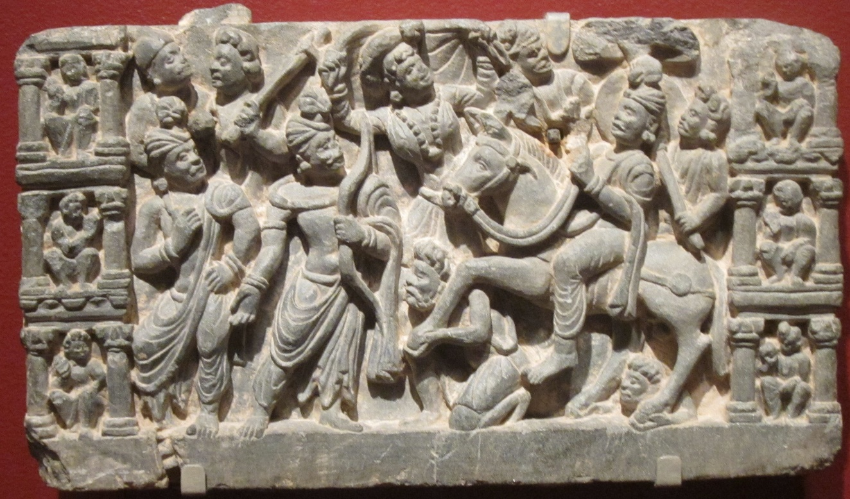

**Prince Siddhartha leaves the Palace riding his horse amidst gathering of his family and friends [13]**

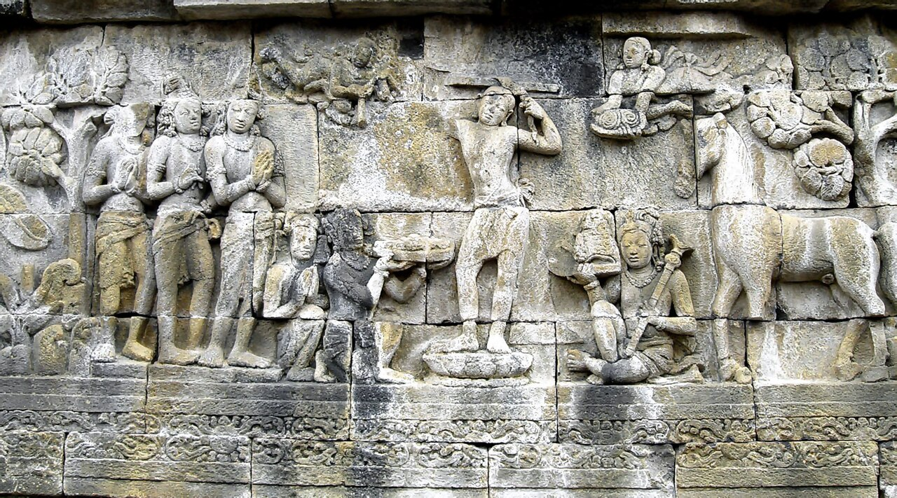

**Prince Siddhartha shaves his hair and becomes an ascetic [14]**

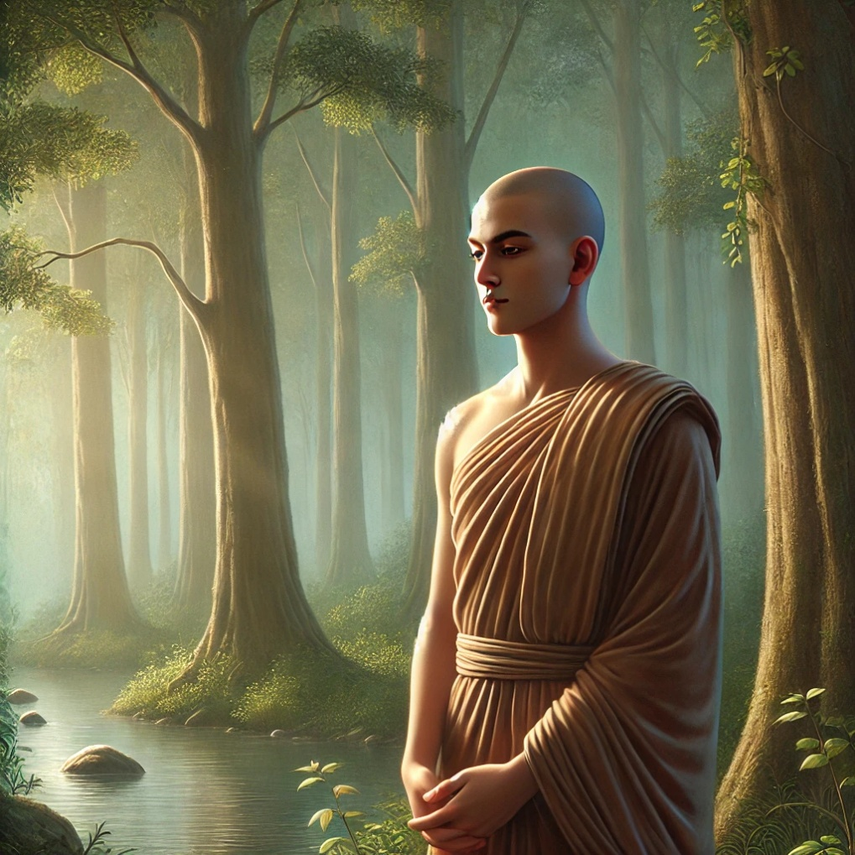

**Ascetic Siddhartha reflecting on his new freedom beside the river Anoma [15]**

## The Wanderings of Ascetic Siddhartha

After renouncing lay life, Ascetic Siddhartha embarked on a profound journey in search of the *Truth*. As we have seen earlier, the Blessed One later reflected on this period, stating:

*“…I performed a difficult and strenuous exercise for six years…” [16]*

The exact sequence of events during these years is not entirely preserved in the scriptures, as there are gaps in the recorded accounts. To bridge these gaps, references from other sources have been incorporated, all of which are detailed in the endnotes. The key milestones in his journey are summarized below:

# The Journey of Ascetic Siddhartha: Key Milestones

**Age 29: The Great Departure—**Leaving Kapilavattu to Seek Liberation

On a full moon day of Āsāḷha (*Esala*, the month of April), Prince Siddhartha set forth on his great quest—to transcend suffering and discover the path to true liberation. [17]

### 1) The Departure from the palace

According to the *Mahāparinibbāna Sutta* (*DN 16*), the Buddha later recalled:

*“I went forth seeking what is good—twenty-nine years of age I was…”*

Other sources provide additional details:

In the year 595 B.C., on a full moon night of Āsāḷha, Prince Siddhartha left his palace, riding his faithful horse, Kaṇṭhaka, accompanied by his devoted companion, Channa. [18]

The *Commentary to the Saṃyutta Nikāya (Spk)* identifies this Channa as the Bodhisatta’s charioteer—the one who guided him out of Kapilavattu on the day of his great renunciation. [19]

**2)** The First Seven Days of Renunciation

* Traveling tirelessly, the prince covered a vast distance of thirty *yojanas* (approximately 450 km, with one *yojana* being about 15 km).
* Upon reaching the banks of the Anoma River, he dismounted, cut off his hair, cast aside his princely garments, and donned the simple robes of an ascetic.

He then spent seven days at the serene *Anupiya Mango Grove*, deeply contemplating his renunciation, embracing the peace and freedom of his new life. [20]

**Thus began the extraordinary journey of Ascetic Siddhartha—one that would lead to the ultimate awakening, bringing light to the world.**

### 3) Anupiya Mango Grove to Rājagaha city

**According to other sources:** from Anupiya Mango grove the recluse Siddhartha walked thirty yojanas towards Magadha province and arrived at city of Rājagaha and stayed in a cave of Pandava Mountain outside the city. There he went round the city for alms and the King Bimbisara, the ruler of Magadha saw him and met him in the cave [21].

**According to scriptures:** Ascetic Siddhartha arrived at Rājagaha and went for alms round in the city, then King Bimbisara saw him and was impressed with his good looks and serene manner followed him to the Pandava Mountain and paid respect, inquired about his clan and requested to live in the kingdom with him. As stated above in this section, Ascetic Siddhartha refused the offer [22].

### 4) From Rājagaha wandering in Magadha looking for teachers

**According to scriptures:** Ascetic Siddhartha met Āḷāra Kālāma*,* a well-known teacher of Magadha and learned under him, understood deep meditation but realised that teaching would not guide him to escape from suffering. Then he met another famous Magadhan teacher, **Uddaka Rāmaputta**, studied under him and came to know that teaching too would not guide to what he believed—freedom from suffering —and left him [23]

### 5) From the monastery of Uddaka Rāmaputta to Senani Village in Uruvela, Magadha

**According to scriptures:** After leaving the hermitage of Uddaka, Ascetic Siddhartha wandering in stages arrived in beautiful forest grove in Uruvelā and decided to settle down there near the river bank of Neranjaana. Then the five group of ascetics: Kondanna, Vappa, Baddhiya, Mahanama and Assaji [24] attended to Ascetic Siddhartha [25]

6) Striving for enlightenment **:**near the river bank of Neranjanā in Uruvel āforest (now called Bodh Gaya) from the age twenty-nine to thirty-five.

**According to scriptures** this is the period Ascetic Siddhartha performed extreme ascetic practices with the five group; the five-group of ascetics lived with him hoping to see he gains enlightenment [26].

## Finding a Suitable Place to Strive

The Blessed One described his search for the ideal place to undertake his ascetic practice in the following way:

*“Still in search, bhikkhus, of what is wholesome, seeking the supreme state of sublime peace, I wandered through the Magadhan country in stages until I eventually arrived at Uruvelā, at Senānigama. There, I saw a serene and agreeable place—a delightful grove with a clear-flowing river, its banks smooth and pleasant, and a nearby village for alms.*

*I reflected: ‘This is a peaceful and suitable place—an ideal setting for the striving of one intent on the path.’ And so, I sat down, resolved in my determination: ‘This will serve for striving’” [27]*

This tranquil setting, with its natural beauty and quiet surroundings, became the place where Ascetic Siddhartha engaged in his intense spiritual quest—one that would ultimately lead to the realization of the highest truth.

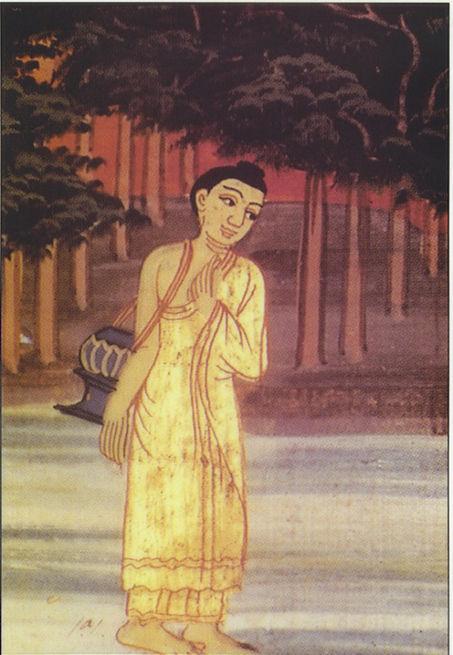

**Acetic Siddhartha looking for a suitable place** **to meditate [28]**

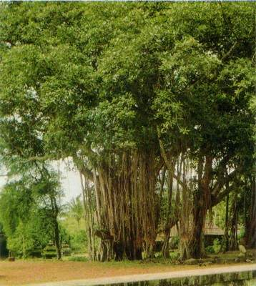

**Present day picture of Uruvela Forest Grove (Bodh Gaya) [29]**

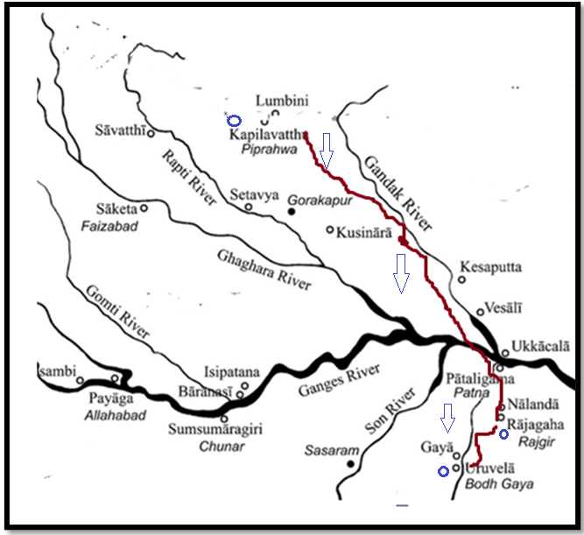

**Map1: Tthe route of Ascetic Siddhartha ‘s wandering from Kapilavattu to Uruvela**. Distance: Kapilavatthu to Rajagaha about 518 km, Rajagaha -Uruvela about 71 km.

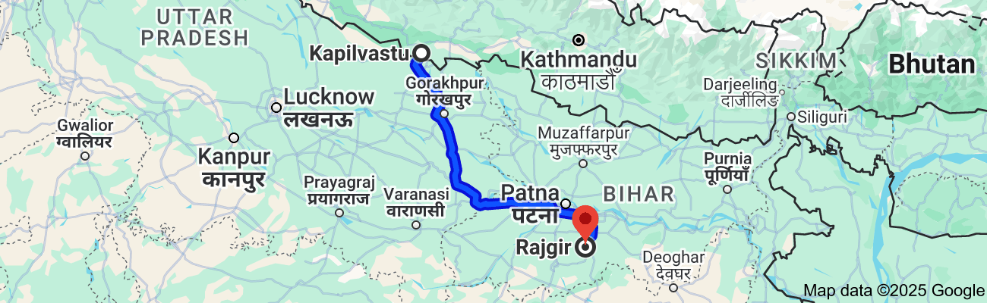

Map2: Modern day road map from Kapilvastu (Nepal) to Rajgir: 518.7 km. [30]

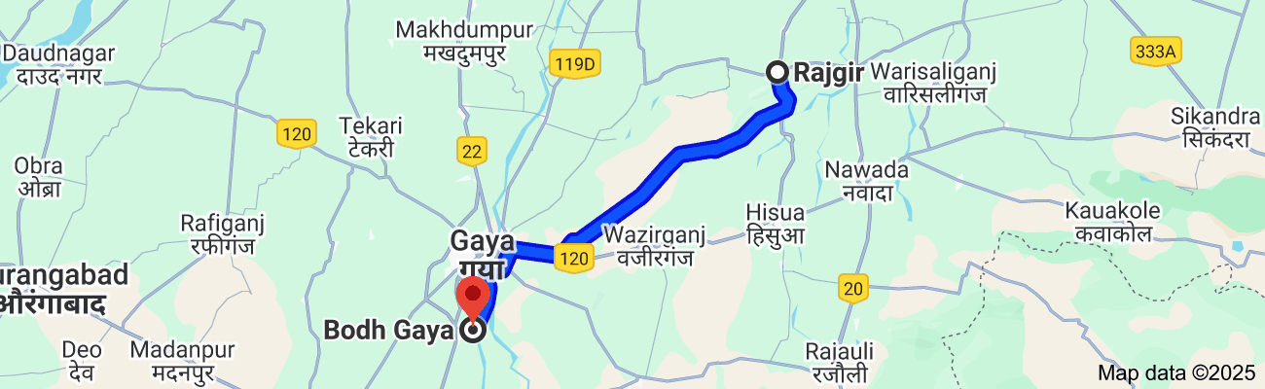

Map 3: Modern day road map from Rajgir to Bodh Gaya (Uruvela). Distance: 71.2 km. [31]

# Important Events in the Life of Ascetic Siddhartha

During his years of wandering in search of truth, Ascetic Siddhartha encountered several pivotal figures who shaped his journey.

## Encounter with King Bimbisāra of Magadha

The *Pabbajjā Sutta* of the *Sutta Nipāta* describes this meeting: [32]

*"The Buddha-to-be arrived at Rājagaha, the mountain stronghold of the Magadhans. As he wandered for alms—his bearing noble, his presence radiant—King Bimbisāra saw him from his high palace and, marveling at his extraordinary appearance, said:*

*‘Behold, sirs, this young ascetic—handsome, majestic, and serene!  
His gaze lowered, his mindfulness unwavering—surely not one of low birth.  
Go quickly, my messengers, and find out where this noble mendicant is bound.’”*

Intrigued by the young ascetic, the king went to meet him and offered him a life of royal pleasure, saying:

“You are but a youth, strong and radiant,  
Endowed with beauty and noble stature,  
Fit to lead an army in battle,  
Surrounded by warriors and elephants.  
I offer you pleasures—enjoy them!  
But first, tell me of your birth.”

Yet, Ascetic Siddhartha firmly declined, replying:

“Seeing the danger in sensual pleasures,  
Seeing renunciation as the true refuge,  
I choose to strive for the highest goal—  
That is where my mind delights.”

This moment is significant because it marks the first recorded instance where the Buddha-to-be explicitly states his reason for renunciation. His unwavering determination to seek liberation rather than indulge in worldly pleasures serves as a powerful inspiration—especially for those who have chosen the monastic path. Through his own example, the Buddha seems to say:

**I have overcome the pull of sensual pleasures for the sake of freedom—you can too!**

## Encounters with the Teachers Āḷāra Kālāma and Uddaka Rāmaputta

In the *Ariyapariyesanā Sutta* (*MN 26*), the Buddha explained why he sought out these two teachers during his ascetic life:

“Having gone forth, bhikkhus, in search of what is wholesome,  
Seeking the supreme state of sublime peace,  
I went to Āḷāra Kālāma… (and later to Uddaka Rāmaputta)  
To lead the holy life in this Dhamma and Discipline.” *[33]*

The Buddha frequently emphasized the value of learning under a wise and virtuous teacher. In the *Cankī Sutta* (*MN 95*), he described the qualities of a good teacher, highlighting the importance of proper guidance on the spiritual path.

At the same time, he also taught that if a seeker realizes that their teacher’s guidance is insufficient for true liberation, they should move on. This was precisely what Ascetic Siddhartha did when he found the teachings of his mentors inadequate.

### Of Āḷāra Kālāma’s teachings, he later reflected:

*“...but it occurred to me: ‘This Dhamma does not lead to enlightenment, to Nibbāna,  
but only to reappearance in the base of neither-perception-nor-non-perception.’  
Not being satisfied with that Dhamma, disappointed with it, I left.”* [34]

This pivotal decision demonstrated his unwavering resolve—not to settle for partial truths, but to seek the ultimate realization of Nibbāna.

### On Uddaka’s Teaching:

*“This Dhamma does not lead to disenchantment, to dispassion, to cessation, to peace, to direct knowledge, to enlightenment, to Nibbāna, but only to reappearance in the base of neither-perception-nor-non-perception*.”  
Not being satisfied with that Dhamma, disappointed with it, I left.”

This reflects Ascetic Siddhartha’s realization that even the deepest meditative attainments, as taught by these two teachers, were not sufficient to bring an end to the cycle of *saṃsāra*. He understood that true liberation required something beyond temporary states of absorption—it required the complete cessation of suffering. [35]

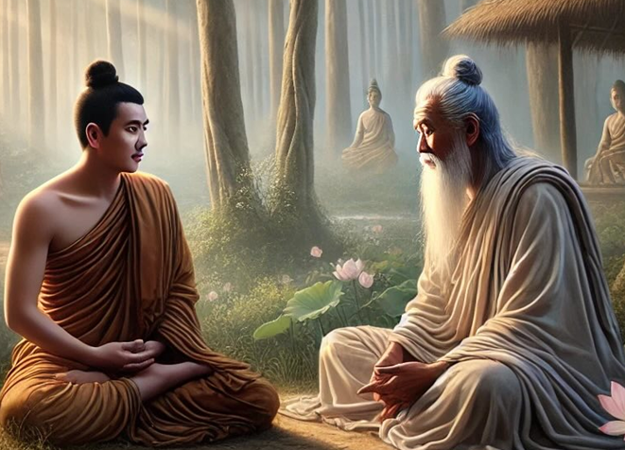

**Ascetic Siddhartha learning under the teacher Āḷāra Kālāma [36]**

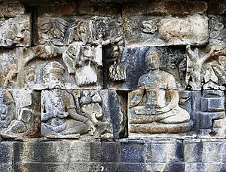

**Ascetic Siddhartha meeting Uddaka Rāmaputta [37]**

## The Intense Austerities at Uruvelā

During his arduous search for the truth, the Bodhisatta pushed himself to the very limits of human endurance. Reflecting on his extreme ascetic practices, he recounted:

*“I thought: ‘What if I were to practice breathless meditation?’ So, I held my breath, ceasing the in-breaths and out-breaths through my mouth and nose. As I did so, a loud sound of wind rushed from my earholes, like the roar of a blacksmith’s bellows.*

*Yet, though tireless energy was aroused in me and unwavering mindfulness was established, my body was strained and unsettled, for I had been worn down by the sheer intensity of my painful striving…”*[38]

Despite his fierce determination, he came to realize that self-mortification was not the path to liberation. His body weakened, yet the truth he sought remained beyond reach. This turning point would lead him to discover the Middle Path—the way of wisdom, balance, and true awakening.

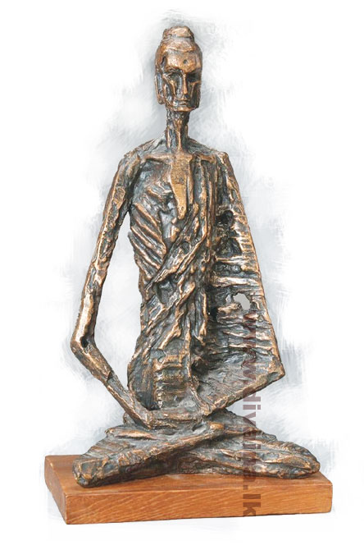

**Extreme ascetic practice of bodhisattva [39]**

## The Buddha’s Reflection on His Extreme Austerities

In a conversation with Venerable Sāriputta, one of his chief disciples, the Blessed One recounted the severe ascetic practices he had undertaken before his enlightenment:

“Sāriputta, I remember living a holy life possessing four qualities. I was an ascetic—supremely ascetic; I was coarse—supremely coarse; I was scrupulous—supremely scrupulous; I was secluded—supremely secluded…

Such was my asceticism, Sāriputta, that I went naked, rejecting conventions, licking my hands, and refusing invitations. Dust and dirt accumulated on my body over the years, caking and flaking off, just like the bark of a tindukā tree shedding its layers over time…

Such was my scrupulousness that I remained mindful even in stepping forward and stepping back, feeling compassion for even the tiniest creatures in the crevices of the ground.

Such was my seclusion that I would retreat deep into the forests, fleeing from grove to grove, from thicket to thicket, from hollow to hollow, avoiding the sight of cowherds, shepherds, or wood gatherers…” *[40]*

Through this account, the Buddha illustrated the futility of extreme austerities. Having pushed himself to the limits of physical endurance, he realized that neither indulgence in sensual pleasures nor self-mortification could lead to enlightenment.

*“…but by this harsh practice of austerities, I have not attained any superhuman states, any distinction in knowledge and vision worthy of the noble ones. Could there be another path to enlightenment?” [41]*

It was through this profound realization that the Bodhisatta abandoned the extremes of asceticism and rediscovered the Middle Path—a path of balance, wisdom, and deep meditation leading to insight and liberation.

*“I reflected: ‘I recall that, when my father the Sakyan was occupied, I sat in the cool shade of a rose-apple tree, secluded from sensual pleasures and unwholesome states, and I entered the first jhāna, accompanied by applied and sustained thought, filled with rapture and pleasure born of seclusion. Could this be the path to enlightenment?’*

Then, as I recalled that experience, I knew: *‘Indeed, this is the path to enlightenment’* [42]

Thus, the Ascetic Siddhartha embraced the Middle Way, demonstrating to the world that true awakening lies not in extremes but in deep meditation, wisdom, and right understanding. He pointed out to us that pleasure of deep samadhi- Jhanas bring only wholesome and peace. This is important for mediator, as it shows that the pleasures-bliss come out from deep mediation should not be discard as it is part and partial of the practice. He describes the Fourth Jhana (of the eight Jhanas), a state of equanimity:

## The Role of Meditative Joy and Physical Strength in the Path to Enlightenment

The Bodhisatta realized that the joy arising from deep meditation—**jhāna**—was pure, wholesome, and peaceful. He pointed out that this meditative bliss should not be rejected, as it is an essential part of the path. He described the **fourth jhāna**, a state of profound equanimity:

*“With the abandoning of pleasure and pain…I entered upon and abided in the fourth jhāna… But such pleasant feeling that arose in me did not invade my mind and remain…*

*I thought: ‘Why am I afraid of that pleasure that has nothing to do with sensual pleasures and unwholesome states?’*

*I realized: ‘I am not afraid of that pleasure, since it has nothing to do with sensual pleasures and unwholesome states’”* *[43]*

This passage marks a shift in the Ascetic Siddhartha’s understanding of pleasure. Unlike the fleeting pleasures of the senses, which lead to attachment and suffering, the joy of meditative absorption is born of seclusion and detachment. It is a necessary and beneficial aspect of the spiritual path, helping to stabilize the mind and deepen insight.

### Rebuilding Strength for the Final Striving

Recognizing that his body needed strength for the deep meditative attainments required for awakening, the Bodhisatta decided to take food again:

“*I ate some solid food—some boiled rice and porridge. At that time, five ascetics were attending to me, thinking: ‘If our recluse Gotama attains some higher state, he will inform us.’ But when they saw me eating boiled rice and porridge, they were disgusted and abandoned me, saying: ‘The recluse Gotama now lives in luxury. He has given up his striving and returned to indulgence’*” [44]

These five ascetics—**Koṇḍañña, Bhaddiya, Vappa, Mahānāma, and Assaji**—would later become the first disciples of the Buddha after hearing his first sermon. Their initial misunderstanding highlights an important lesson: true renunciation is not about self-torture but about wisdom—the ability to discern the Middle Path between indulgence and self-mortification.

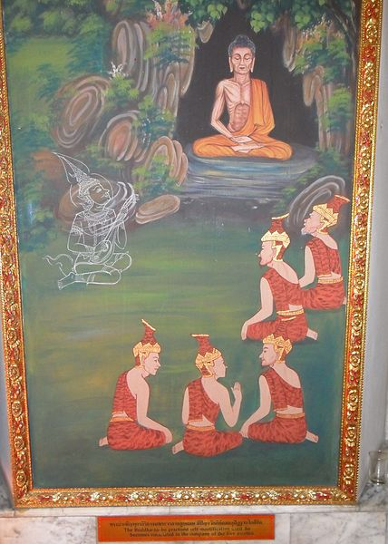

**Ascetic Siddhartha and his five attendants in Uruvela forest grove [45]**

### Summary

* The section refers to his learning path - meeting the two teachers: Āḷāra Kālāma and Uddaka Rāmaputta and experiencing extreme deprivation with the Group of Five ascetics.

* The Buddha realised that deep meditation without insight and extreme austerity and deprivation would not lead to enlightenment. He realised that he needed to find the middle path.

In the next section: section:4, narrates how Ascetic Siddhartha found the right way and attained the supreme Buddhahood.

### End Notes: Section 3

1. [Tapa Shotor](https://en.wikipedia.org/wiki/Tapa_Shotor) monastery in [Hadda](https://en.wikipedia.org/wiki/Hadda,_Afghanistan), Afghanistan, 2nd century CE, Source: <https://en.wikipedia.org/wiki/Tapa_Shotor>
2. Chapter3: The Great Chronicles of Buddhas by Venerable Mingun Sayadaw
3. DN: 16( Mahāparinibbāna Sutta 5.27 section The Great Passing).
4. At the time of the Parinibbāna of the Buddha, out of compassion for Subhadda, the Blessed One taught the Dhamma. Afterwards, he sought ordination and the Buddha said to Venerable Ananda: ‘Let Subhadda go forth!’, and he became a monk and an Arahant. See: DN: Note:446, p.195.
5. MN: 36 Mahāsaccaka sutta.
6. AN3:39
7. Ibid.
8. Chapter3: The Great Chronicles of Buddhas by Venerable Mingun Sayadaw
9. Source: Buddha-Vamsa-Pali & Chariya Pitaka Pali: 25 Gotama Buddha Vamsa: Vol.33. by Buddha Jayanti Tripitaka Series.
10. Four Sights of Buddha – Old Age, Sickness, Death & Monk: Source: The Stone Studio

    <https://www.thestonestudio.in/gautam-buddha-story-of-wisdom-enlightenment/>
11. MN: 26 (Ariyapariyesena Sutta- The Noble Search)
12. This episode is mentioned in Section 2 of this compilation.
13. Source: Wikipedia: Pakistan, Gandhara, schist, 2nd-3rd century, San Diego Museum of Art
14. [Borobudur](https://en.wikipedia.org/wiki/Borobudur), 8th century Author: [Gunawan Kartapranata](https://commons.wikimedia.org/wiki/User:Gunkarta) : Source: <https://en.wikipedia.org/wiki/The_Buddha#/media/File:Siddharta_Gautama_Borobudur.jpg>
15. AI generated image via ChatGPT
16. Source: Buddha-Vamsa-Pali & Chariya Pitaka Pali: 25 Gotama Buddha Vamsa: Vol.33. by Buddha Jayanti Tripitaka Series.
17. Chapter3: The Great Chronicles of Buddhas by Venerable Mingun Sayadaw.
18. Ibid.
19. See: SN: Note:179, p. 11294. He later became a disciple of the Buddha, Bhikkhu Channa becoming an arahant is described in SN:22: 90 .
20. Chapter3: The Great Chronicles of Buddhas by Venerable Mingun Sayadaw.* According to <http://gorakhpurandgautambuddha.blogspot.com/> Anoma River is now called River Ami in Siddharthnagar * Ami is a tribute of Rapti river.
21. Chapter3: The Great Chronicles of Buddhas by Venerable Mingun Sayadaw.
22. Snp:3.1 (Pabbaja Sutta)
23. MN: 26 (Ariyapariyesana sutta)
24. * The five group later became the first 5 disciples of the Buddha are: Koṇḍañña, Bhaddiya, Vappa, Mahānāma, and Assaji also the first 5 arahants in Buddha’s dispensation. * Ttradition says that ascetic Koṇḍañña from Kapilavatthu was the youngest of the eight persons summoned by King Suddhodana to the naming event of prince Siddhartha. He declared that the prince would definitely leave the lay life and attain enlightenment. He was keenly watching the progress of the prince and when the prince renounced and became an ascetic, he went with four of his friends: and also became ascetics living in the Deer Park of Isipathana and hearing that the bodhisatta reached Uruvela came there to look after him.
25. See: MN: 26 (Ariyapariyesana sutta), MN:36 (Maha Sachchaka sutta), MN:85 (Bodhirajakumara sutta).
26. Ibid.
27. MN:26. (Ariyapariyesana sutta).
28. Source: <http://nobleclass.weebly.com/buddhism-begins-in-india.html>
29. Source: nichiren-etudes.net
30. Map source: Google.*Deepak Anand in his blog says: We are told the Bodhisattva Siddhārtha’s  ‘great going forth’ (mahāpravrajyā/mahāpabbajjā) took place on the night of the Āṣāḍha (Āṣhāla) full moon (i.e. full moon of July). The Buddha-to-be left the Palace in the middle of the night and moved in stages touching Rāmagrāma, river Anomā, Vaiśālī and Rājagriha arrived at Uruvelā. My best calculation through mapping and experience is that he traveled 600kms. <https://nalanda-insatiableinoffering.blogspot.com/2022/01/kapilavastu-palace-city-witness-to-two.html>. He is A guide, explorer, independent researcher, and enthusiast of the life of the Buddha.
31. Map Source: Google.
32. Snp:3.1.
33. MN:26. (Ariyapariyesana sutta).
34. See: MN:26. **Note:** The same description of the bodhisattva’s disappointment about the two teachers is also stated in MN: 36 (Mahāsaccaka sutta ) & MN:85 (Bodhirājakumāra sutta)
35. See: MN: Note: 302.
36. Source: <https://elliottelford.com/alara-kalama/>
37. Source: Wikipedia: [Gautama Buddha](https://en.wikipedia.org/wiki/Gautama_Buddha) ( as an ascetic) meets the Uddaka Rāmaputta (left) in one of the bas-reliefs recounting the stages leading up to [awakening](https://en.wikipedia.org/wiki/Bodhi), [Lalitavistara](https://en.wikipedia.org/wiki/Lalitavistara_S%C5%ABtra#The_Borobudur_reliefs), [Borobudur Temple Compounds](https://en.wikipedia.org/wiki/Borobudur_Temple_Compounds) 8th and 9th century, first corridor, main wall.
38. MN:36.
39. sculpture by Sri Lankan artist: Tissa Ranasinghe,: Source: Divaina.lk
40. MN.12 (Mahā Sihanāda sutta).
41. MN:36.
42. MN:36. **Note**: During the Bodhisattha’s boyhood as a prince, on one occasion his father led a ceremonial ploughing at a traditional festival of the Sakyans. The prince was brought to the festival and a place was prepared for him under a rose-apple tree. When his attendants left him to watch the ploughing ceremony, the prince, finding himself all alone, spontaneously sat up in the meditation posture and attained the first jhāna through mindfulness of breathing. When the attendants returned and found the boy seated in meditation, they reported this to the king, who came and bowed down in veneration to his son (MN :Note: 389).
43. Mn:36.
44. MN:36.
45. Source: <https://commons.wikimedia.org/wiki/File:Gautama_Siddhartha_as_an_ascetic.JPG>